Exp No: 14: Determination and plotting of Polarization in different Dielectric Medium with their relative permittivity and to find electric susceptibility.
Date:
Aim:
To determine and plot polarization in different dielectric medium with their relative permittivity and to find electric susceptibility.
Software required:
• SCILAB version 6.0.1
Code:
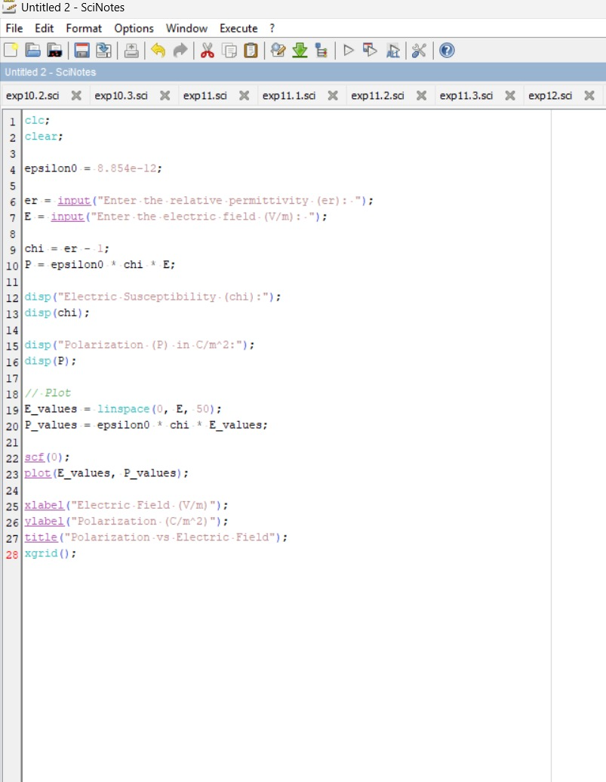

Output:
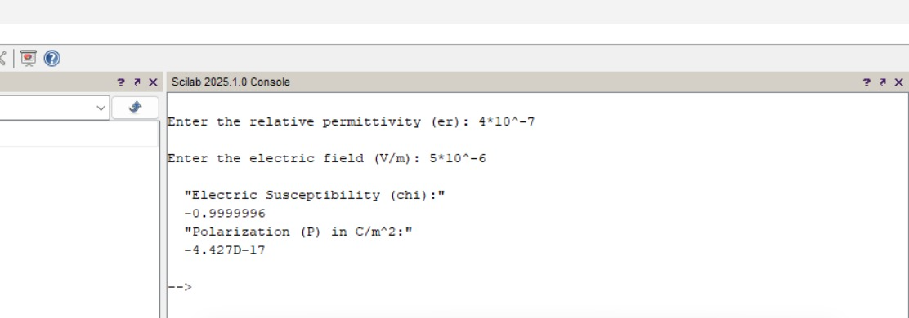
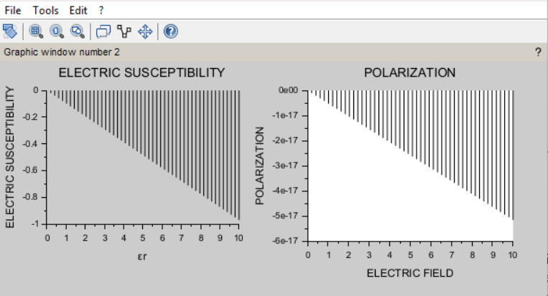
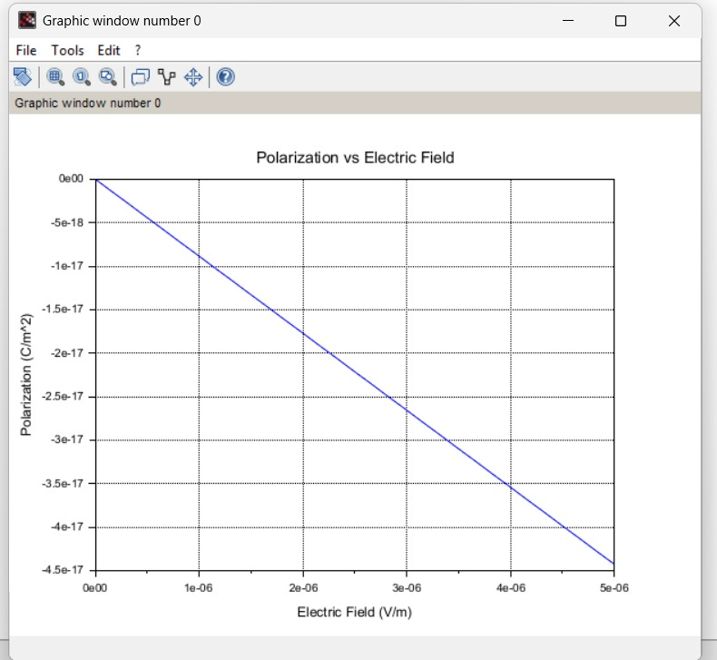
Analytical problem:
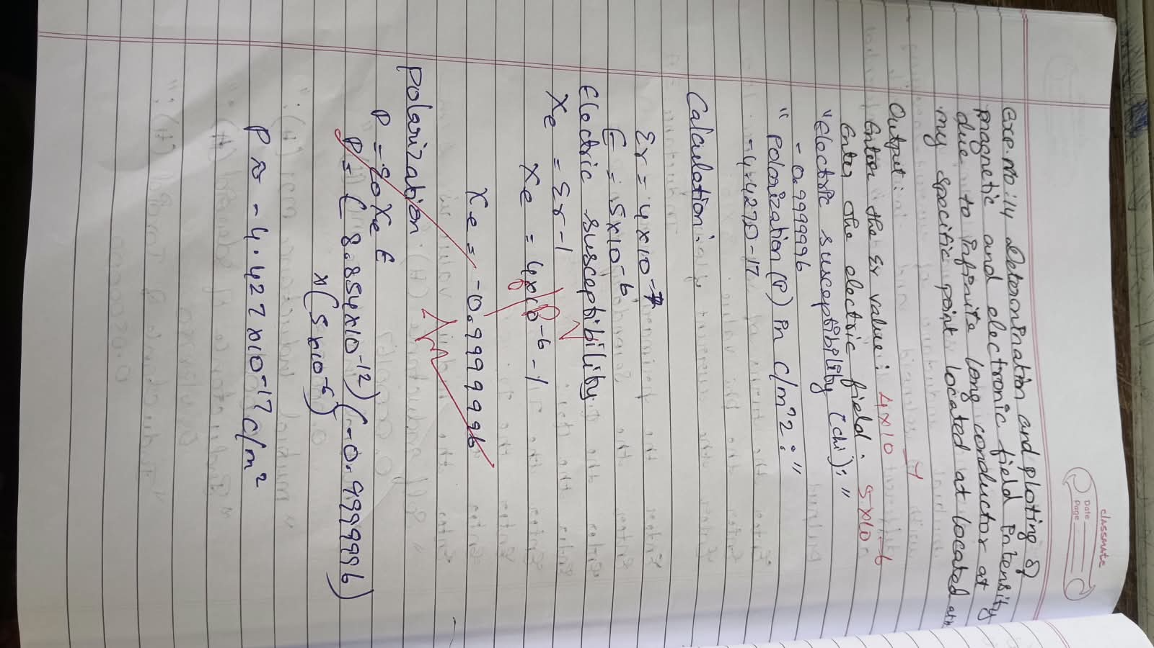

Case 1: To determine and plot the polarization and electric susceptibility of electromagnetic waves in three dielectric media: Air, Water, and Glass, using their relative permittivity.
Analytical:
Determine and plot the polarization and electric susceptibility of electromagnetic waves in three dielectric media: Air, Water, and Glass, using their relative permittivity.
- Air:
  - Relative Permittivity: ϵr=1
  - Electric Susceptibility: χe​ (to be calculated)
- Water:
  - Relative Permittivity: ϵr=80
  - Electric Susceptibility: χe
- Glass (e.g., Borosilicate Glass):
  - Relative Permittivity: ϵr=6
  - Electric Susceptibility: χe
Code:
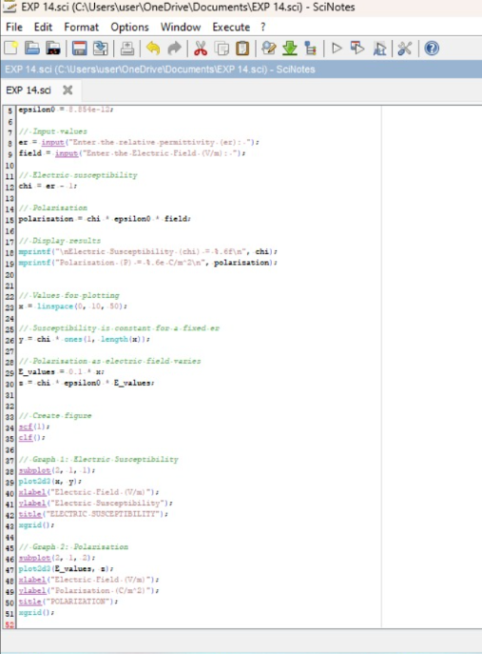
Output:
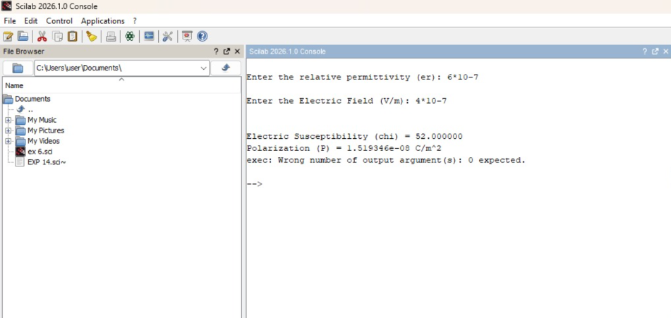
Graph:
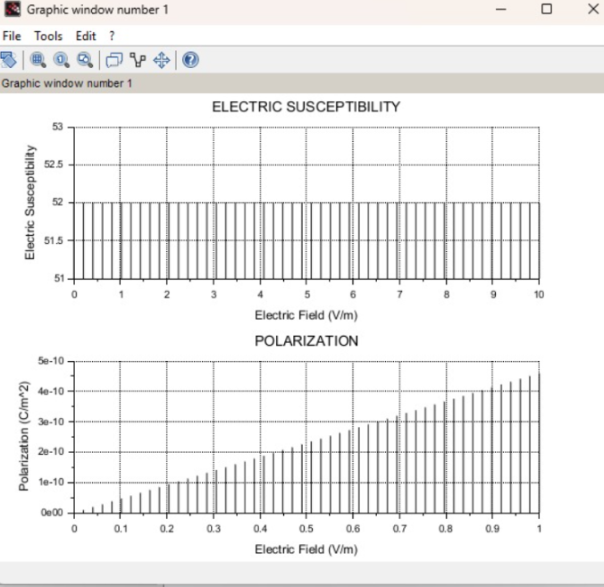
Case 2: To calculate and plot the polarization and electric susceptibility in Silicon, Teflon, and Paper, and understand how their relative permittivity affects the polarization.
Analytical:
To calculate and plot the polarization and electric susceptibility in Silicon, Teflon, and Paper
- Silicon:
  - Relative Permittivity: ϵr=11.7
  - Electric Susceptibility: χe​
- Teflon:
  - Relative Permittivity: ϵr=2.1
  - Electric Susceptibility: χe​
- Paper:
  - Relative Permittivity: ϵr=3.0
  - Electric Susceptibility: χe​
Code:
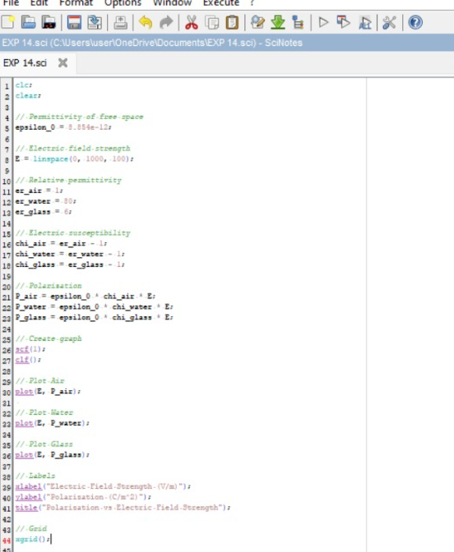
Output:
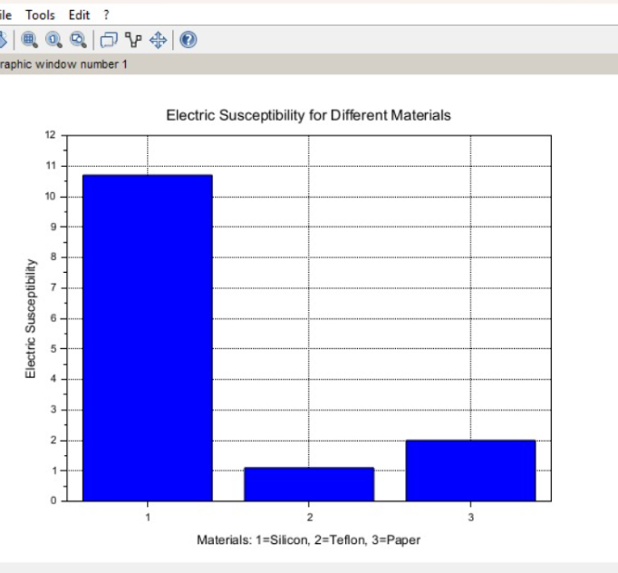

Case 3: To explore how different dielectric materials (Rubber, Oil, and Plastic) affect the polarization and electric susceptibility, and to compare their relative permittivity’s.
Analytical:
Calculate how different dielectric materials (Rubber, Oil, and Plastic) affect the polarization and electric susceptibility, and to compare their relative permittivity’s.
- Rubber:
  - Relative Permittivity: ϵr=3.5
  - Electric Susceptibility: χe
- Oil:
  - Relative Permittivity: ϵr=2.2
  - Electric Susceptibility: χe​
- Plastic (e.g., Polyethylene):
  - Relative Permittivity: ϵr=2.3
  - Electric Susceptibility: χe​
Code:
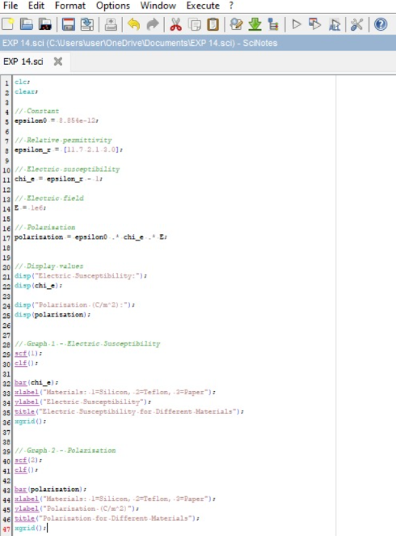

Output:
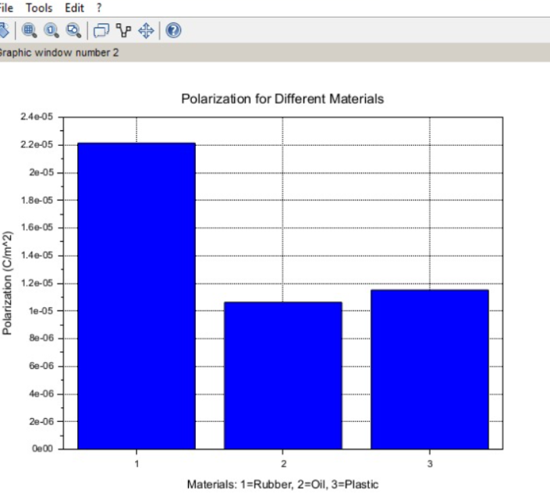

Case 3: To examine how the magnetic flux density (B) in a ferromagnetic material changes with different values of magnetic field intensity at constant length and width.
Conditions:
- Material: Soft iron (same as in the previous studies)
- Length (L): Constant at 10 cm
- Width (W): Constant at 5 cm
- Magnetic Field Intensity (H): Varies from 200 A/m to 2000 A/m (i.e., 200 A/m, 500 A/m, 1000 A/m, 1500 A/m, 2000 A/m)


